**Regression**

**TOTAL POINTS 9**

1.Question 1

Which figure represents an overfitted model?

1 point



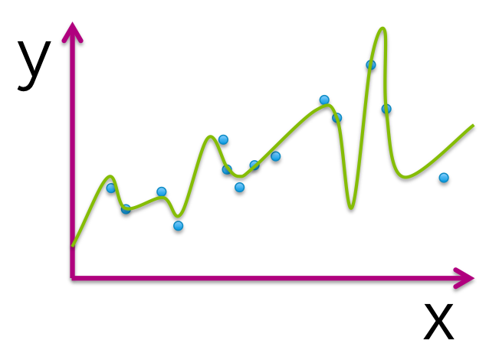



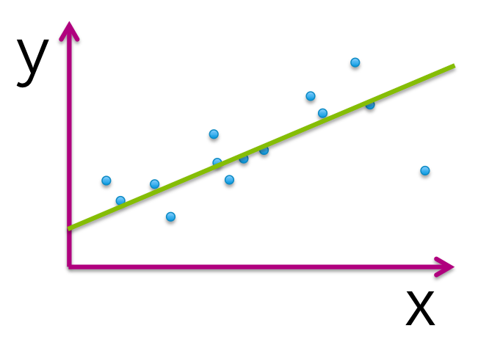



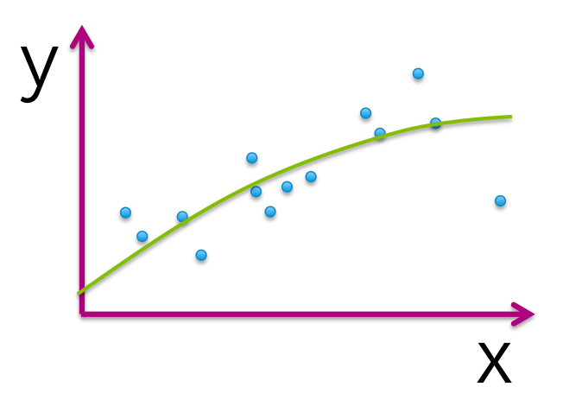

2.Question 2

***True or false:*** The model that best minimizes training error is the one that will perform best for the task of prediction on new data.

1 point



**True**



**False**

3.Question 3

The following table illustrates the results of evaluating 4 models with different parameter choices on some data set. Which of the following models fits this data the best?

|  |  |  |
| --- | --- | --- |
| Model index | Parameters (intercept, slope) | Residual sum of squares (RSS) |
| 1 | (0,1.4) | 20.51 |
| 2 | (3.1,1.4) | 15.23 |
| 3 | (2.7, 1.9) | 13.67 |
| 4 | (0, 2.3) | 18.99 |

1 point



**Model 1**



**Model 2**



**Model 3**



**Model 4**

4.Question 4

Assume we fit the following quadratic function: f(x) = w0+w1*x+w2*(x^2) to the dataset shown (blue circles). The fitted function is shown by the green curve in the picture below. Out of the 3 parameters of the fitted function (w0, w1, w2), which ones are estimated to be 0? *(Note: you must select all parameters estimated as 0 to get the question correct.)*

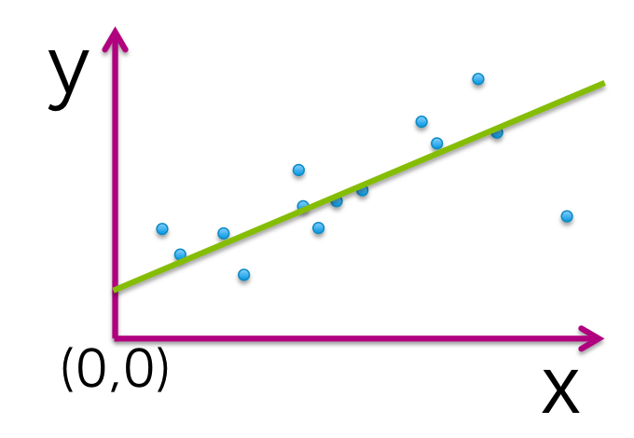

1 point



**w0**



**w1**



**w2**



**none of the above**

5.Question 5

Assume we fit the following quadratic function: f(x) = w0+w1*x+w2*(x^2) to the dataset shown (blue circles). The fitted function is shown by the green curve in the picture below. Out of the 3 parameters of the fitted function (w0, w1, w2), which ones are estimated to be 0? *(Note: you must select all parameters estimated as 0 to get the question correct.)*

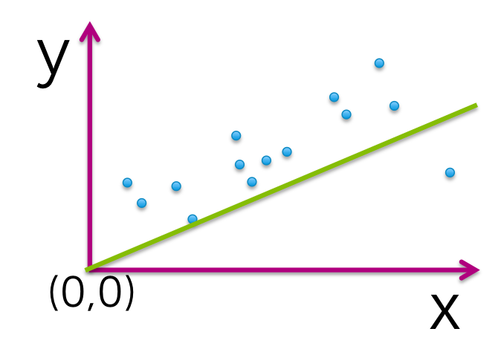

1 point



**w0**



**w1**



**w2**



**none of the above**

6.Question 6

Assume we fit the following quadratic function: f(x) = w0+w1*x+w2*(x^2) to the dataset shown (blue circles). The fitted function is shown by the green curve in the picture below. Out of the 3 parameters of the fitted function (w0, w1, w2), which ones are estimated to be 0? *(Note: you must select all parameters estimated as 0 to get the question correct.)*

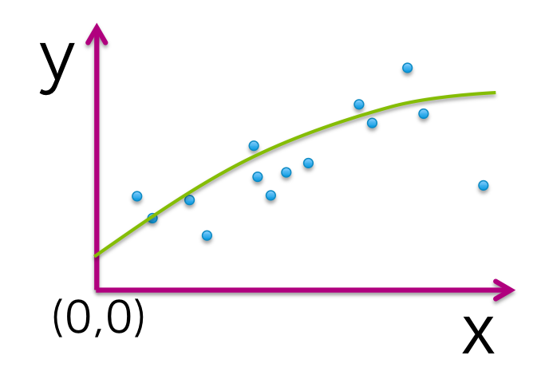

1 point



**w0**



**w1**



**w2**



**none of the above**

7.Question 7

Assume we fit the following quadratic function: f(x) = w0+w1*x+w2*(x^2) to the dataset shown (blue circles). The fitted function is shown by the green curve in the picture below. Out of the 3 parameters of the fitted function (w0, w1, w2), which ones are estimated to be 0? *(Note: you must select all parameters estimated as 0 to get the question correct.)*

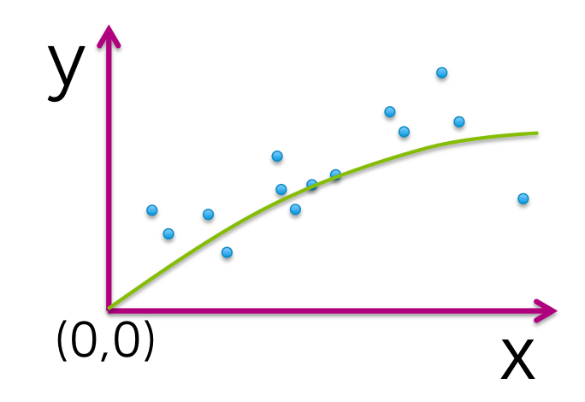

1 point



**w0**



**w1**



**w2**



**none of the above**

8.Question 8

Which of the following plots would you ***not*** expect to see as a plot of training and test error curves?

1 point



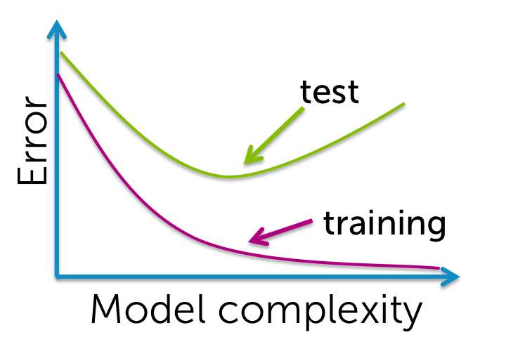



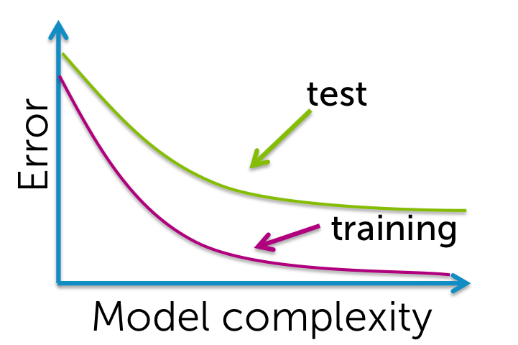



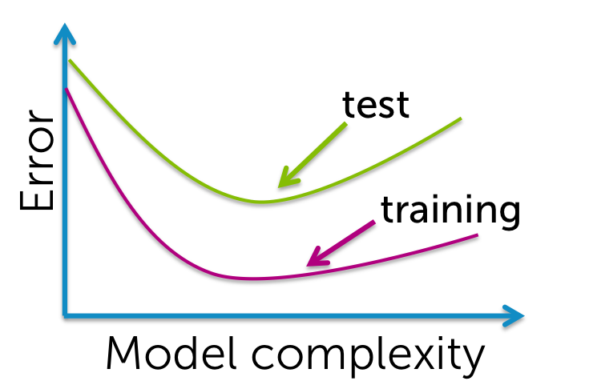

9.Question 9

***True or false:***One always prefers to use a model with more features since it better captures the true underlying process.

1 point



**True**



**False**